Industry Readiness Program Details

Overview
A 15-contact-hour certificate course designed to bridge the gap between academic knowledge and industrial requirements in the pharmaceutical, biotechnology, food, healthcare, and allied life sciences sectors. The course introduces participants to Quality Assurance (QA), Quality Control (QC), Good Laboratory Practices (GLP), Good Manufacturing Practices (GMP), biosafety, regulatory requirements, and industrial laboratory practices.

Learning Outcomes
- Understand industry structures, career pathways, and current workforce requirements.
- Apply Good Documentation Practices (GDP), including SOPs and laboratory records.
- Understand QA and QC roles, procedures, and quality management systems.
- Interpret international quality standards, including ISO standards.
- Apply GLP and bio safety principles in laboratory operations.
- Understand risk assessment, laboratory safety, equipment calibration, and regulatory compliance.
- Develop industry-oriented laboratory skills and professional awareness.

Topics Covered
- Life Science Industry Structure & Skill Gap Analysis
- Career Opportunities & Industry Expectations
- Good Laboratory Practices (GLP)
- Laboratory Quality Systems
- SOPs & Good Documentation Practices (GDP)
- Biosafety & Risk Assessment
- PPE, Hazard & Waste Management
- Quality Assurance (QA) & Quality Control (QC)
- Good Manufacturing Practices (GMP)
- Quality Management Systems
- QC Testing & Batch Records
- Validation & Calibration
- Deviation Handling & CAPA
- ISO Standards
- Audits & Regulatory Compliance
- Industrial Case Studies

Eligibility
Students, Faculty Members, and Industry Professionals from Biological, Pharmaceutical, and Allied Life Sciences

Date: 22 August, 29 August 5 September 2026

Total Registrations: 84 Participants

Trainers:
- Mr. Syed Muhammad Imran
- Mr. Ehtisham Asif
- MR. Jehan Zaib Arshad

Registration Fees: PKR 1500/-

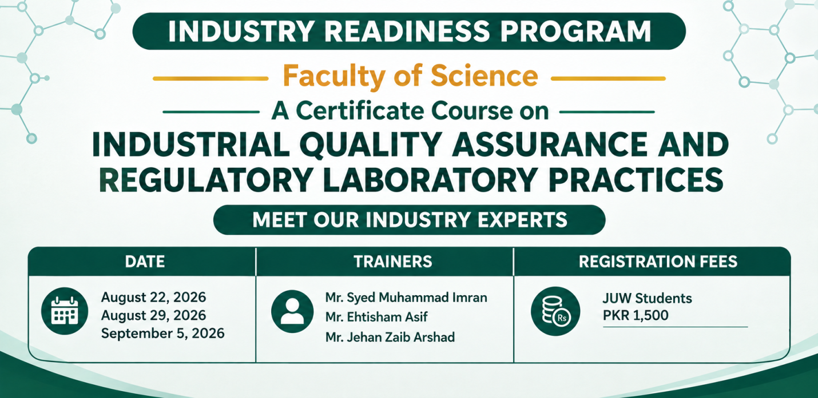

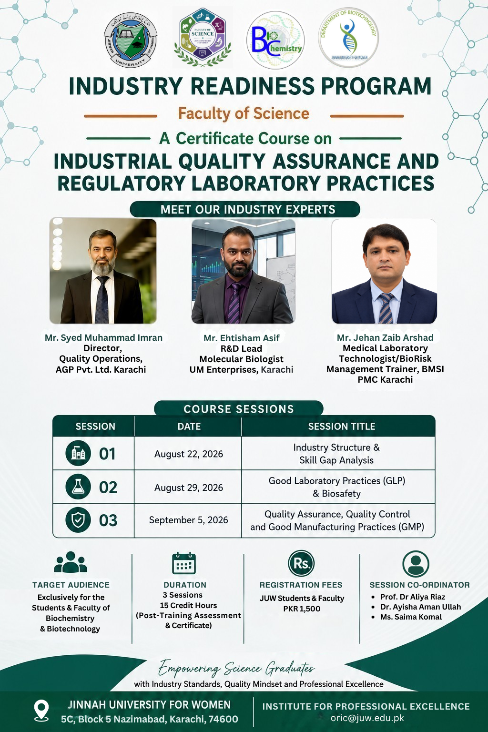

Overview
A practical industry-readiness program designed to bridge the gap between academic microbiology and the practical requirements of the food industry. The course focuses on food safety, microbiological analysis, contamination control, HACCP-based preventive systems, quality assurance, and real-world industrial applications.

Learning Outcomes
After completing the program, students will be able to:
- Identify major microbial hazards associated with food and food-processing environments.
- Differentiate between foodborne pathogens, indicator organisms, and spoilage microorganisms.
- Describe appropriate microbiological approaches for assessing food safety and quality.
- Explain the seven principles of HACCP and their application in food-processing operations.
- Identify potential hazards and critical control points within food-processing processes.
- Develop greater awareness of food safety, quality assurance, and industry practices.

Topics Covered
- Microbiological Analysis: A Tool for Food Safety and Quality Assurance
- From Farm to Fork: Ensuring Food Safety through HACCP
- Real-World Applications of Microbiology in Food Safety and Quality Excellence

Eligibility
BS Microbiology students of 3rd and 4th year, with basic knowledge of Microbiology and Microbiological Laboratory Techniques.

Trainers
- Dr. Abdul Basit Khan — Principal Scientific Officer, PCSIR Laboratories
- Ms. Shazia Naz — Director Quality Control, Marine Fisheries Department, Ministry of Maritime Affairs, Government of Pakistan
- Ms. Hareem Fatima — Assistant Manager, Department of Microbiology, National Foods Pvt. Ltd.

Date: 2, 3 & 5 September 2026

Time: 9:00 AM – 2:00 PM

Venue: Muhammad Uzair Auditorium

Registration Fee: JUW Students & Teachers: Rs. 1,500/-
